Zonta International District 10
The Sara Metcalf Scholarship Award Program: 2019
History
The Sara Metcalf Scholarship Award is given in honor of a former Zontian from the Zonta Club of Shreveport, Louisiana. Mrs. Metcalf was a member of Zonta for many years. Having served as local, district, and international Z Club Committee Chairperson, Metcalf was instrumental in the formation and guidance of the Z Club and Golden Z Club programs. Mrs. Metcalf died in 1992. District 10 of Zonta International developed this scholarship award in her honor in 1994, with the first $500.00 award being presented in 1996.
Purpose
The Sara Metcalf Scholarship Award Program was established to encourage Z Club and Golden Z Club members to enter careers or seek leadership positions in social policy making, government, and volunteer organizations.
This scholarship is designed to encourage all to participate in school, community, national, and international service projects. Additionally, the Sara Metcalf Scholarship Awards Program provides a public relations opportunity at the club and district levels to project the goals of Zonta International. As local communities follow the applicants to the district level, they will learn about the dimensions of Zonta International and its global efforts to improve the status of women worldwide.
Who May Apply
- Current high school senior Z Club members who have been a member for a minimum of two years.
- Current Golden Z Club members who have been a member for a minimum of two years.
Requirements
- Completed application
- Copy of school transcript
- Two letters of recommendation (one from a faculty member of the school sponsoring a Z Club or Golden Z Club and one from an adult, non-family member who knows the applicant on a personal as well as academic and social level.)
Judging Criteria (Local and District levels)
Applications will be judged based on the following five categories:
- School Service Activities
- Community Service Activities
- International Service Activities
- Effectiveness of Service Work
- Goals for use of Scholarship
Timeline
- Applications of all local level winners must be received by the District Z Club and Golden Z Club Committee chairperson by April 1 of each year.
- Winner(s) will be announced on May 1 of each year
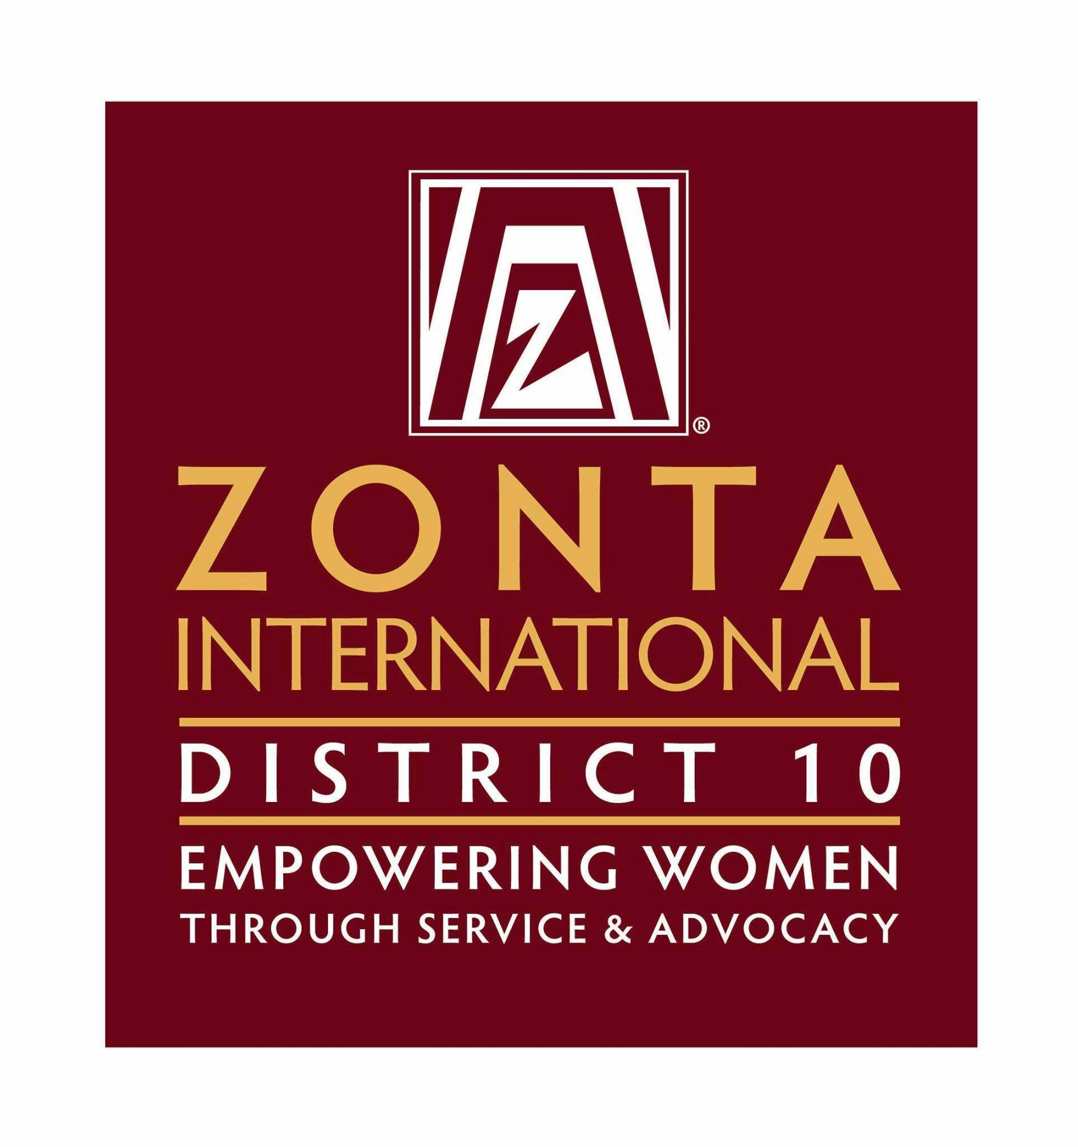

Zonta International District 10
Sara Metcalf Scholarship Award Program Application
*Please type

Name:
Last First Middle Initial
Address:
Street (include house, apartment, P. O. Box, route and/or highway number)

City State Zip Code

Home Phone: ( ) Email:_____________________________________

Date of Birth:
Month Day Year
School Name:

School Address:
Physical Address

City State Zip Code

Major or Interested Course of Study:

Number of Years in Z Club Golden Z-Club

Golden Z-Club Member: Were you a Z Club member? If so, where:

List all Z Club or Golden Z Club offices held:
Offices | From – To (month/year)

Essay Information

Applicant’s Name:
Last First Middle Initial

Applicant’s School Name:

*Please describe in 50 words or less your participation with your Z Club or Golden Z Club in each service project listed below. (You may use an additional sheet, but make sure your name and school’s name is typed at the top of the sheet.)

School Service:

Community Service:

International Service:

*As a result of your service work mentioned in the three areas on the previous page, state in 50 words or less how this work has affected you.

*If you were awarded this scholarship, how would you use the money (Educational and financial goals)?

Signature___________________________ Date ___________________

Zonta International District 10
Sara Metcalf Scholarship Award Program Application
Letter of Recommendation Form
*This form is to be completed by a faculty member of the school sponsoring the Z Club or Golden Z Club and an adult, non-family member who knows the applicant on a personal as well as academic and social level.

Recommendation for:
(Applicant’s Name)

Note: The individual named above is applying for a Z Club or Golden Z Club scholarship award. Please submit a letter of recommendation on her behalf, based on the following information:

~Applicant’s accomplishments

~Applicant’s awareness of women’s and community issues

~Applicant’s motivation for volunteerism

~Applicant’s potential for future public service

*Also include how well you know the applicant and in what capacity.

